**A short Interview with Program Quality Director on Pathways**

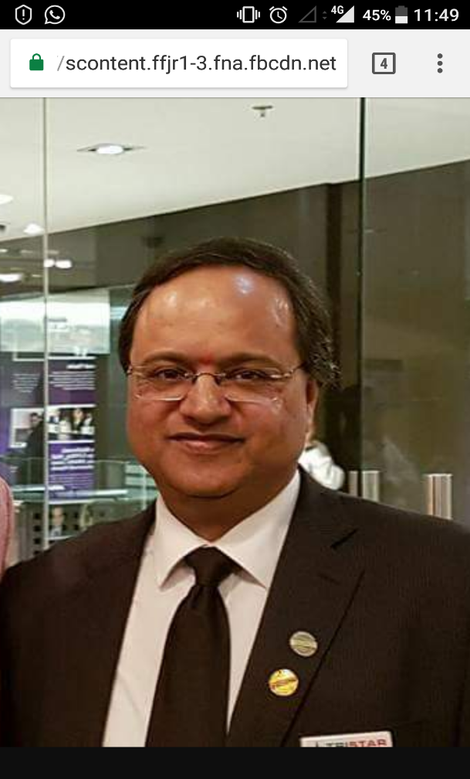

**1. Why there is a big deviation from the simple CC and CL track to the complicated Pathways?**

I learnt long ago that the only thing which is constant in this world is CHANGE. Pathways is not complicated. It is just a change from the past to the present. The world is moving forward at a rapid pace and technology along with the latest generation of human beings is moving at an even rapid pace. What we learnt earlier may become obsolete very soon. Therefore, based on various inputs, Toastmasters has taken this decision to change their Education program to Pathways. Pathways has different paths which are professional and members can receive awards as well as certifications in each of these paths. Basically, it will help you grow more professionally than earlier.

**2. Based on your experience, how easy to roll out Pathways in District 105, especially while considering the technical knowledge of majority of our members.**

Team work is Dream work. I think this is the theme of one of the Areas. When a team comes together, nothing is difficult. The Pathways Ambassadors and Guides are doing a fantastic job by visiting clubs all over the District and explaining to the clubs about the program, how can they take it forward, how will it benefit them etc., They have also provided inputs to the FAQ which has now grown on the TMI website. We are already on the path to launching this program in D105 by the 20th March as per schedule.

I don't think it is difficult for people to learn some online skills. Pathways is a simple program which has a base camp online. While we spent many years with TM without even logging on to the website and depended on professionals who do so regularly, it is time for all of us to enhance our skills. Simple steps towards learning the online material and processes will benefit a lot. Changing the culture will take a little bit more time but I am sure it won't take long.

**3. Are you confident of a successful roll out?**

With the responses to the above two questions, I think you must have pretty well imagined that I am not only confident but also very positive and motivated that this will be a successful roll out. In fact, D105 might be the District which will roll it out successfully 100% in the region.

**Nagabhushan Balaji, DTM**

**Program Quality Director, 2017-18**

**District 105, Region 11**

**Toastmasters International**

**Where Leaders Are Made**

**Tel:**[**+971 50 6562797**](tel:+971%2050%20656%202797)

**Tel:**[**+971 55 3374937**](tel:+971%2055%20337%204937)

**Email:**[**balajibhushan@yahoo.co.in**](mailto:balajibhushan@yahoo.co.in)

